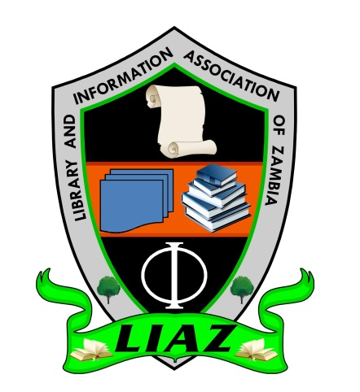

Library and Information Association of Zambia

“Libraries … Linking People with Information”

ZAMBIA

COUNTRY REPORT 2012 - 2014

by
Velenasi Mwale Munsanje
LIAZ PRESIDENT
SCECSAL XXI

INTRODUCTION
The Zambia Library and Information Association of Zambia (formerly Zambia Library Association) is happy to share the SCECSAL Zambia country report for the period 2012 to 2014, highlighting various successes and challenges faced. Zambia has a population about 13,092,666 people, and over 50% of this population aged 18 years and below and this huge category of people creates challenges in the educational sector. However, the country has made great efforts in promoting access to information in various educational institutions.

ASSOCIATION MEMBERSHIP
The association has an average membership of fully paid up members of about 100 and about 150 members that closely participate in association activities.

CHANGE OF NAME
The association changed its name from Zambia Library Association (ZLA) to Library and Information Association of Zambia (LIAZ) in 2013. The association has in the recent years improved in the membership recruitment by including more records managers and officers, registry clerks, archivists, etc. in addition to the huge number of librarians.

LIBRARY LEGISLATION
The long pending Library Legislation fight has continued to make steady progress. INASP funded a stakeholders meeting in 2012 to draft the National Library Policy document that was submitted through the Zambia Library Service to the Ministry of Education to respond to the Ministry of Education, Science, Vocational Training and Early Education together with the draft Library Bill. Despite the long period taken by government to respond to the submission, the government this year appointed a sixteen member committee comprising key librarians and other stakeholders to spearhead the finalization of both the National Library Policy document and the Library Bill in readiness for inclusion in the Education Act which is currently under review.

CONTINUING CAPACITY DEVELOPMENT
In response to the SCECSAL 2012 resolution on the need for library and information professionals to endeavour to acquire skills relevant to manage and disseminate information in digital formats, the association conducted the following trainings:
- Registry operations, Paper and Electronic Records Management Training
- Library Automation and Web Information Management Training
- Use of Koha
- Marketing skills for librarians

PARTNERS IN LIBRARY DEVELOPMENT
Various partners have been very instrumental in developing libraries and information provision in Zambia. Government has created a conducive environment to facilitate the sharing and provision of access to information resources in various formats including the digital form. Several partners have worked closely with government and other institutions in promoting this access to information. These partners among others include:
- Zambia Library Service (ZLS)
The Library and Information Association of Zambia has worked closely with the Zambia Library Service in creating awareness of library services in the country. ZLS in collaboration with LIAZ has been at the core of ensuring that the Ministry of Education, Science, Vocational Training and Early Education attends to the pending National Library Policy and Bill. ZLS has also worked closely with other partners such as WiderNet Project in installing digitized libraries in all the ten provinces in Zambia. Other organizations that ZLS works closely with include Lubuto Library Project, UNICEF, Sparkman, and Room to Read.

- WiderNet Project
In this age of digitization and promotion of electronic materials, WiderNet Project has donated and installed the granary to over 45 libraries in Zambia. These include libraries in teacher training colleges, universities (both public and private), schools of nursing, teacher resource centres, medical colleges, Zambia Library Service, secondary schools, among others. This has been very useful in a country with very low, poor and expensive internet access. The installations and digitization has been with the support of the Flemish Association for Technical Co-operation and Development, VVOB, Sparkman Centre for Global Health, IICD, Peace Corps, Ministry of Education, Science, Vocational Training and Early Education in Zambia, Tropical Health and Education Trust and NHS Education Trust of Scotland. The current internet usage is about 6.8% of the country’s population.

- Room to Read
Founded in the year 2007, Room to Read partners with government and other institutions to gaps for early readers. In 2014, it handed over 43 supported school libraries to government. They have been very instrumental in improving library infrastructure and improving access to information through their Library Program. They have also been focussing on the acquisition of life skills among secondary school girls.

- Lubuto Library Project
The Lubuto Library Model was developed to create opportunities for equitable, high quality education and poverty reduction through open access holistic educational, cultural and community programs. Lubuto libraries target the most vulnerable children and youths in Zambia with excellent, comprehensive book collections and programs that enable them to develop their knowledge, talents and self-expression.

With a mission of providing an open system of accessible services to vulnerable children and youths through the two Lubuto Libraries, the Lubuto Library Project enables children to develop the knowledge and skills needed to reconnect with their culture and community and participate fully in society. Currently Lubuto Library Project has currently completed constructing a third library in the Southern province of Zambia

LIBRARY AWARENESS ACTIVITIES
The association has been observing the National Library Week to create awareness to the entire country about the importance and role of libraries and librarians. The association has worked closely in conjunction with the Zambia Library Service in ensuring that these activities are a success. In the recent past, the commemoration of the National Library Week has been held outside the capital city Lusaka to give an opportunity to other towns to host and market the service in their districts.

USE OF SOCIAL MEDIA
The association has continued to use Facebook as a means of communicating to members and also as a discussion forum. Currently the association Facebook account has a membership of over 500. This has greatly helped the association to reach out to many young professionals.

PUBLICATIONS
The association has continued to promote research by professionals by publishing the Association Journal. In addition, the University of Zambia has also launched the Department of Library and Information Studies Journal. This will give library professionals in Zambia and worldwide increased opportunity to publish their works.

OTHER ACTIVITIES
LIAZ has among others participated and contributed to the following activities:
- Review of the School and college Library Manual in Zambia in conjunction with Zambia Library Service.
- Review of the Master’s Program for the University of Zambia
- Recruitment of library staff by various organizations

CHALLENGES
The Library and Information Association of Zambia has amongst others faced several challenges including:
- The low pace taken to enact the Library legislation.

- Ineffective Library Association Provincial branches. There has been very little interest and support shown by members in supporting the provincial branches that have been in existence for some time.

- Most infrastructure remains poor especially in public libraries as well as libraries in rural areas.

