IFLA GLOBAL VISION – TOGETHER WE CREATE OUR FUTURE!
By Velenasi Mwale-Munsanje
The International Federation of Library Associations and Institutions (IFLA) is the leading international body representing the interests of library and information services and their users. It is the global voice of the library and information profession. This September, 2017, IFLA would have been in existence for 90 years.
IFLA is an independent, international, non-governmental, not-for-profit organization whose aims are to:
- Promote high standards of provision and delivery of library and information services
- Encourage widespread understanding of the value of good library & information services
- Represent the interests of our members throughout the world
In pursuing these aims IFLA embraces various core values, one of which is the conviction that delivery of high quality library and information services helps guarantee that access.
Library and Information Association of Zambia has been, and is a member of IFLA. LIAZ seeks to participate fully in IFLA related activities in a quest to provide better library services in Zambia.
IFLA has embarked on facilitating a Global Vision discussion through a series of meetings and workshops in different parts of the world. IFLA has planned various face-to-face and online, future-oriented conversations that will take place in various places around world.
In order to make the library field ready for the future, IFLA requires the input of all experts and librarians in this Global Vision discussion. This discussion is meant to involve all countries of the world. Zambia will participate actively in this process to make this a true global brainstorm.
Having a global vision means that the library profession is not only trying to impact the library, city or country, but the whole world. It means devising a strategy that covers the entire globe.

IFLA believes that creating a global vision for a united and connected library field will help meet the challenges of the future, while achieving one of the true potentials of libraries: to build literate, informed and participative societies.
The first event for the IFLA Global Vision Project was in Athens, Greece on April, 4th 2017 where more than 300 librarians from around the world gathered together. The IFLA President’s Meeting of 2017 and IFLA’s Global Vision Discussion kicked off with representatives from all IFLA Professional Units in April 2017 and reflected on changes and challenges that will be faced by the library field and enthusiastic discussions on the ways to jointly tackle them.
The IFLA Global Vision is an invitation for librarians from all over the world to explore how a united library field can meet the challenges of the future.
Gerald Leitner, IFLA Secretary General says that “We firmly believe that thinking globally and acting locally is the best way to create a Global Vision for a united and connected library field that will help achieving one of the true potentials of libraries: to build literate, informed and participative societies.” The IFLA Secretary General also believes that in order to tackle challenges in the library fields, the solution is not to build walls but to break down walls. He believes the solution is to break down walls in our minds and to break down walls between libraries to improve people’s lives. Therefore, IFLA convenes the library field to develop a global vision for the future of libraries that only a strong and connected library field can achieve.
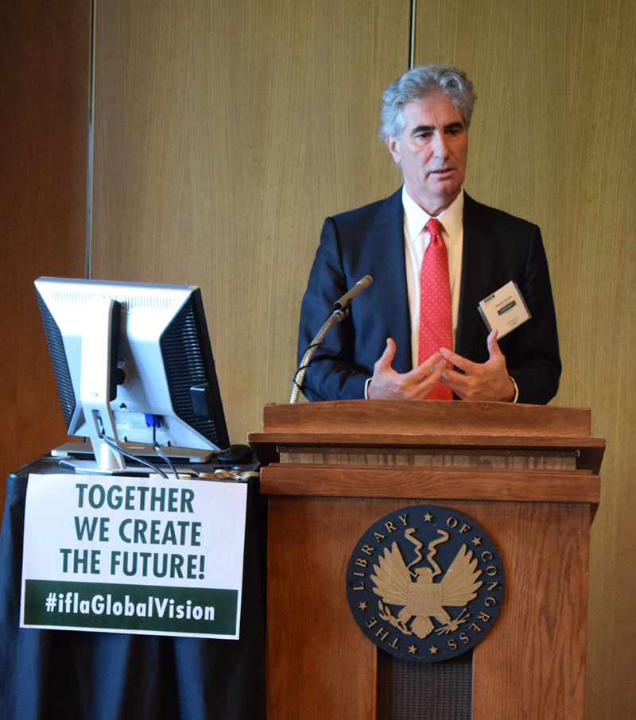
IFLA Secretary General
IFLA as indicated, will conduct various regional workshops to empower regions with knowledge and skills on how to enable countries contribute effectively to the IFLA Global Vision
The first regional workshop of IFLA’s inclusive and high-level Global Vision discussion started on 3 May 2017 in Washington D.C. Major representatives from different types of libraries from Canada and the United States were gathered by IFLA for two days to discuss how a united library field can tackle the challenges of the future.
IFLA President Donna Scheeder echoed the fact that “the issues libraries face today require individual commitment to a joint response in order to successfully achieve a joint vision. Today we begin a very important journey.”

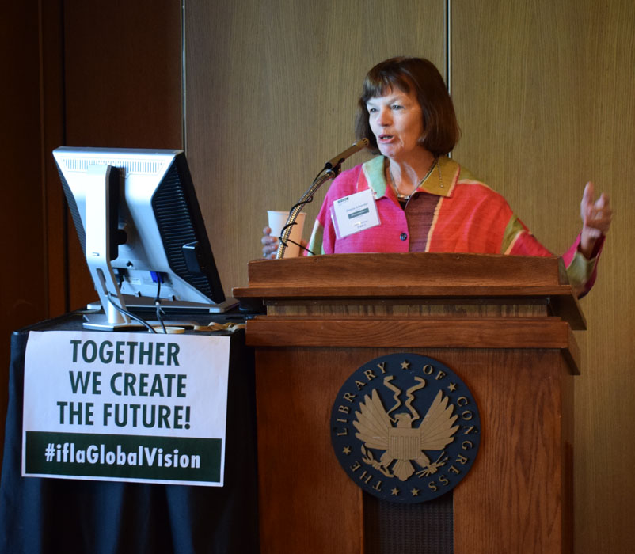
IFLA President

In the aim of attaining this Global Vision, IFLA is following this timeline.
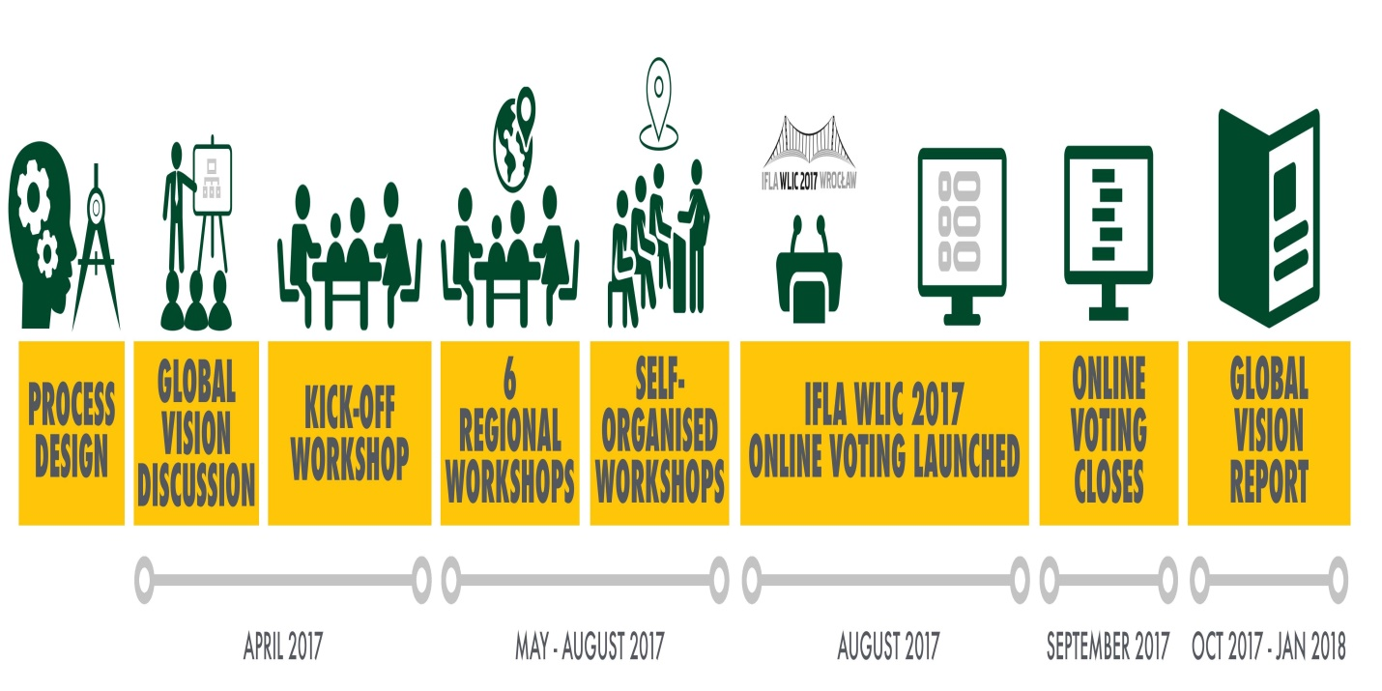
The regional workshop for Africa was held from 14-15 May, 2017 in Yaoundé, Cameroon where, African library community leaders representing 37 countries met to discuss how a united library field can tackle to challenges of the future together. The gathering represented a strong community from the African continent to the global discussion. Zambia was part of this workshop and the library profession in the country was represented by Library and Information Association of Zambia President, Mrs. Velenasi Mwale Munsanje.
IFLA President-elect Glòria Pérez-Salmerón continued to emphasise during the Africa meeting that “We need to create a united library field; no one can do it better than we.” In addition, IFLA Secretary General Gerald Leitner echoed that “We believe that knowledge and expertise to transform the library field exists everywhere”. And because of this, IFLA has organized Vision workshops on all continents with the aim of listening and discussing - and to make all voices heard.

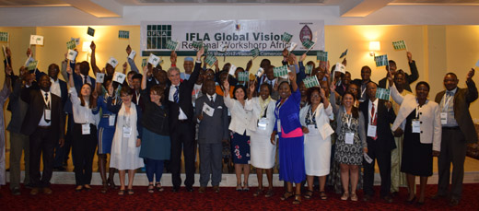
Delegates at the Africa Regional Meeting in Cameroon

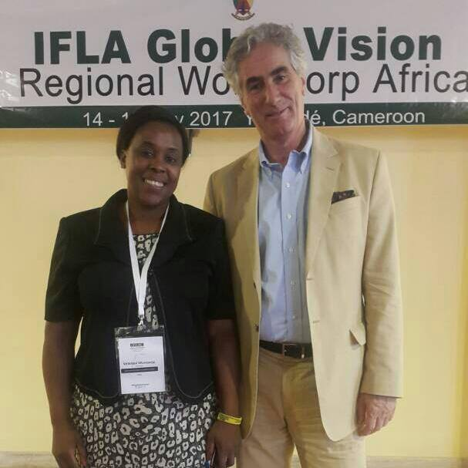
LIAZ President Velenasi Munsanje with IFLA Secretary General
IFLA has since continued with more discussions with other regions of the world.
LIAZ will utilize the forthcoming Annual General Conference for 2017 scheduled to be held in July, 2017 at Lake Safari Lodge in Siavonga to engage librarians in the country over the IFLA Global Vision.
In addition, an online voting system is planned to be launched on the Global Vision website in August, 2017 that will allow active participation in identifying future challenges and prioritizing actions that the library environment could take.
Conclusions from regional and national discussions along with voting data will then be gathered and analyzed by IFLA. This unique material will provide a basis for the IFLA Global Vision report which will be published in early 2018.
All librarians in Zambia are encouraged to have a say in this IFLA Global Vision.
Join the conversation on Twitter and Instagram using the #iflaGlobalVision hashtag

